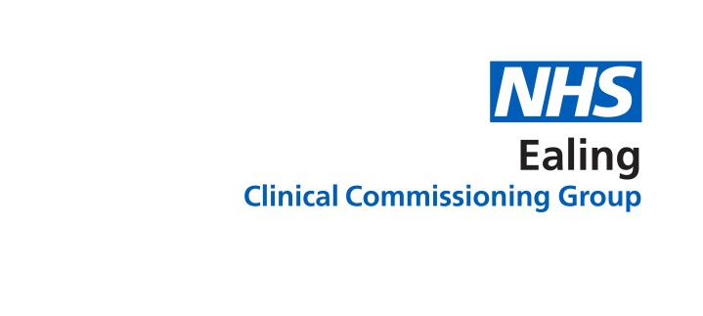
Sharing your medical information
Your choices

Health professionals are trained to keep your records secure and to manage them responsibly and in confidence.

Your GP can now see your medical record held in other health organisations that provide your care e.g. your hospital or health centre. Health professionals e.g. your hospital doctor, district nurse, or physiotherapist treating you can also see your full GP record if you give your permission when they see you.

Sharing your records benefits you because:
- You won’t need to repeat your medical history.
- You avoid unnecessary appointments and tests.
- Your health professional has the right information at the right time.

Please enter your name and dob and select one option for 1) and 2)

Name:……………………………………………………………………………… Date of Birth:……………………………………………

- Your practice sharing your record with other healthcare organisations

Yes, I am happy for my GP practice to share my full medical record with other organisations providing my care.

No, do not share my medical records with other organisations.

N.B. Selecting no might delay your treatment or mean repeated tests. Professionals and emergency departments will not have up to date information.

- GP practice seeing your record from other healthcare organisations

Yes, I am happy for the GP practice to see records held about me by other organisations providing my care.

No, I do not want the GP practice to see records held about me by other organisations.

N.B. Selecting no means that your GP might not have up to date information from other organisations to continue caring for your safety. Mistakes could be made because your information from other organisations is not joined up.

For more information:
Click: http://ealingccg.nhs.uk/patientrecord
Call: 0800 881 5209
Email: sharing.information@nhs.net
Ask: staff at your practice

For practice use only: Set share out & share in preferences on SystemOne

